**TWO WAY ANOVA – two factors (*Bj*)/multiple levels (*Ai*)**

* Each level of one factor is combined with the level of the other.
* Treat all possible combinations of the factors levels.

Ex. 3 recipes (R1, R2, R3) at two oven temperatures (T1, T2) = 3 (Recipes) x 2 (temps) = 6 treatments (R1, T1), (R2, T1), (R3, T1), (R1, T2), (R2, T2) & (R3, T2).

**1. Descriptive Analysis:**

* Arrange the data in spreadsheet format.
* Obtain the means of the treatments.
* Arrange the means in a two-way table according to the two factors.
* Obtain a two way plot of the means.
* Interpret results.

Ex.

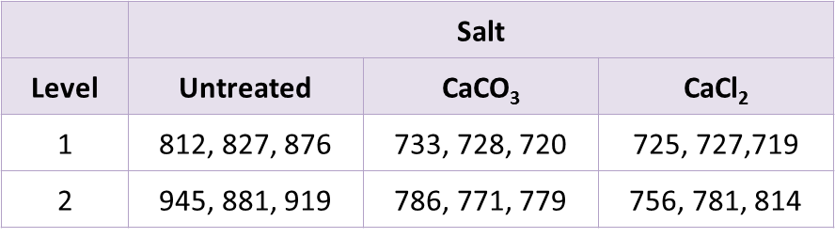 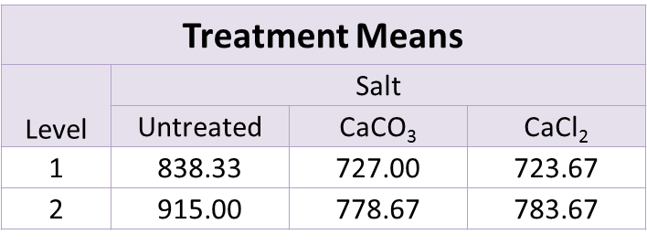 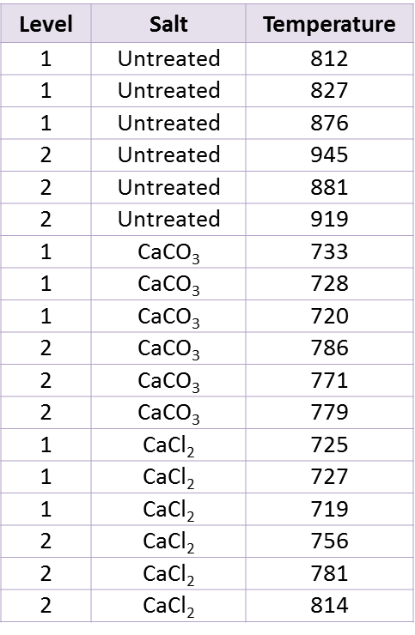 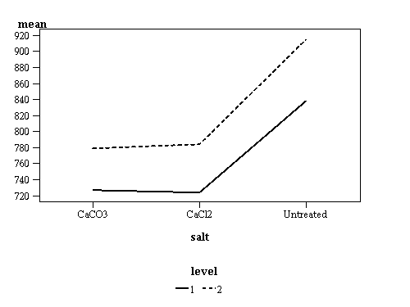

Mean Profile Plot

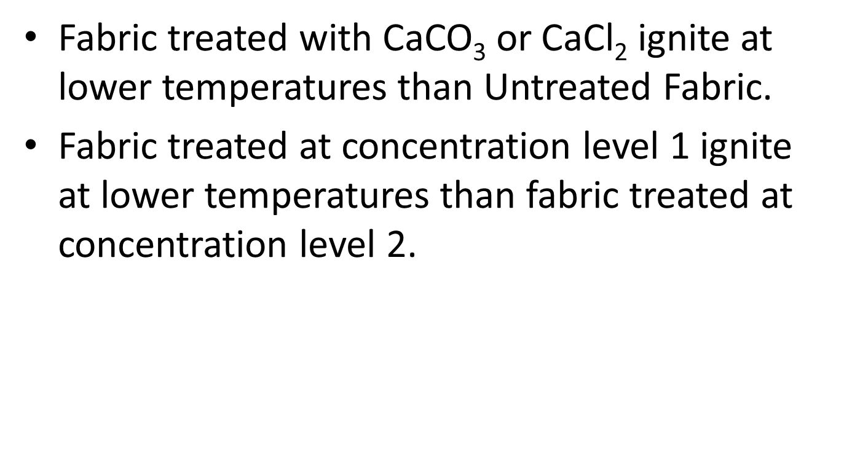

**2. Notation in Tabular Form for Two Way ANOVA:**

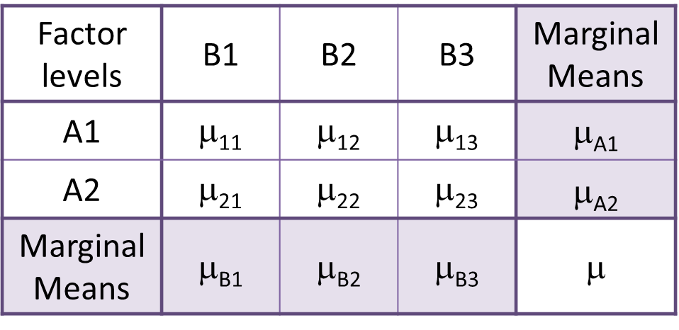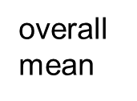

e.g. μB1 = (μ11 + μ21)/2

**3. Population Main Effects:**

* Main effects for factor A are the differences between the marginal means for factor A and the overall mean.
  + Main effect of level Ai = μAi – μ.
* Main effects for factor A are the differences between the marginal means for factor A and the overall mean.
  + Main effect of level Bj = μBj – μ.

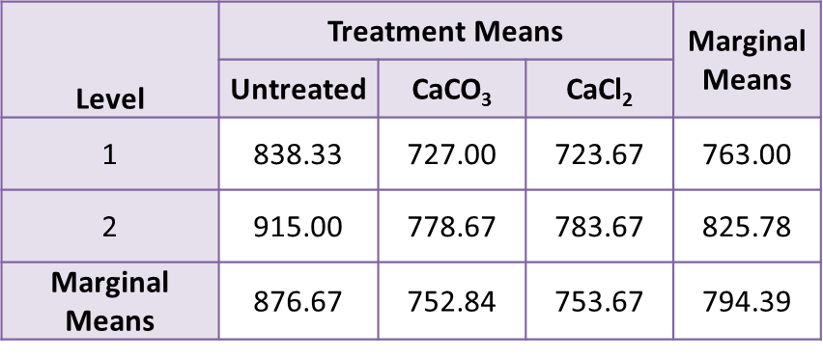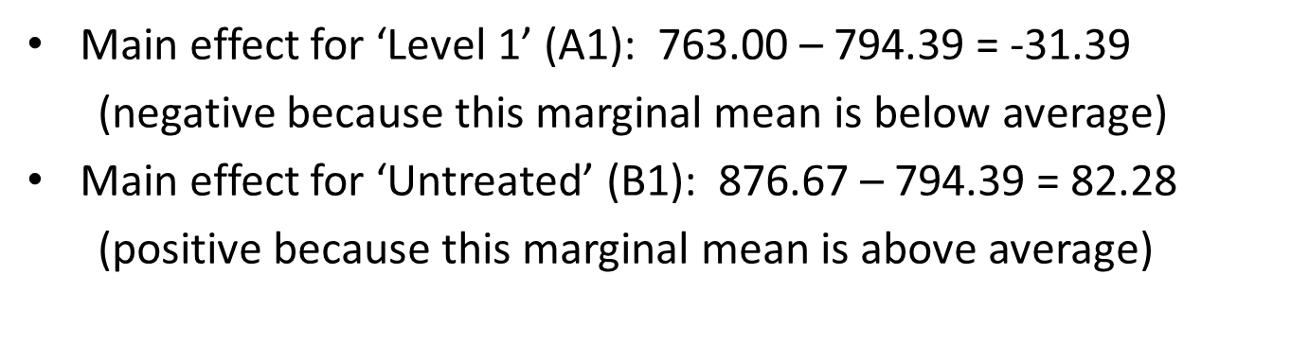

**4. Additive Effects** – the effects of factors A and B are additive if, for all treatment combinations (Ai, Bj), the population mean can be expressed as:

μij = μ + (μAi - μ) + (μBj - μ) or usually written

μij = μ (overall mean) + αi (main effect of Ai) + βj (main effect of Bj)

Additive Model - Yijk = μ + αi + βj + εijk, assuming NIID (0, σ2)

**5. Interaction Effects (αβ)ij** – if one or more treatments have population means that cannot be expressed additively.

(αβ)ij = μij – (μ + αi + βj)

Interaction Model - Yijk = μ + αi + βj + (αβ)ij + εijkassuming NIID (0, σ2).

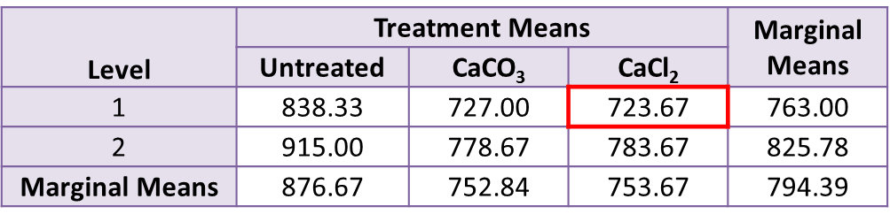



This combination is NOT additive, so there is an interaction. It is not necessary to check the other combinations.

**~ ~ HOWEVER ~ ~**

The difference (between 723.28 and 722.28) seems small , so the interaction may not be statistically significant.

**TWO WAY ANOVA – Hypothesis**

**1. Main effect Hypothesis: defined in terms of the interaction model: Yijk = μ + αi + βj + (αβ)ij + εijk**

* Main hypothesis for factor A:
  + Ho: αi=0 for all levels of A (no main effects)
  + Ha: not all αi’s are 0 (there are main effects)
* Similar effects hypotheses for B, but use βi’s instead of αi.

**2. Main effect and Marginal Means:**

* Ho: marginal means for A are all the same (Ho: αi=0 for all levels of A)
* Ha: marginal means for A are not all the same (Ha: not all αi’s are 0).

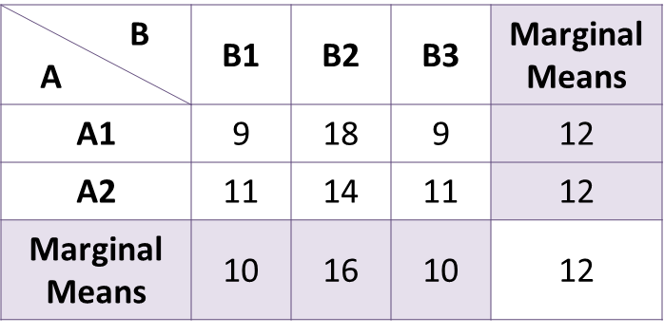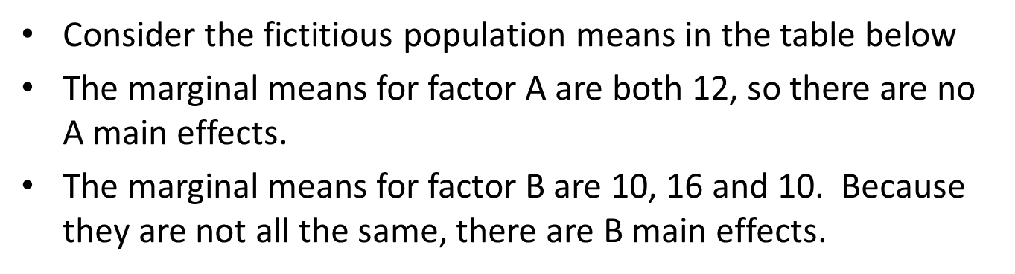

**3. Interaction hypothesis: Yijk = μ + αi + βj + (αβ)ij + εijk**

* Ho: (αβ)ij=0 for all treatments (no interaction)
* Ha: not all (αβ)ij are 0 (interaction) – if there is no interaction, we have an additive model.

To see why this works, consider the contrast involving A1 and A2 with B1 and B2, i.e. (µ11 – µ12) – (µ21 – µ22). With no interaction, the effects are additive so that

µ 11 = µ + α1 + β1 and µ12 = µ+ α1 + β2

When we take the difference, µ and α1 cancel out, so µ 11 – µ 12 = β1 – β2. Similarly, µ21 – µ22 = β1 – β2, so

(µ11 – µ12) – (µ21 – µ 22) = (β1 – β2) – (β1 – β2) = 0.

In other word, the contrast is 0.

Ex.

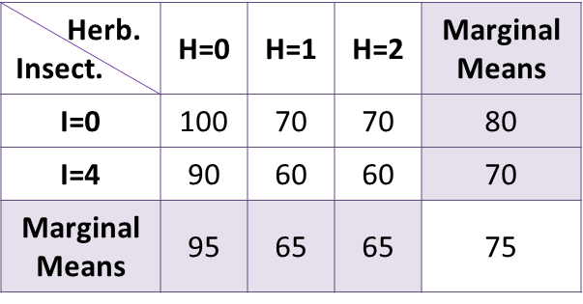

Not equal. Insecticide main effects.

Agronomy Study.

-Two levels of insecticide (0,4)

* Three levels of herbicide (0,1,2)

No interaction between I=0 and I=4.

100-90=70-60=70-60=10. Any contrast differences will be 0. contrast

Not equal. Herbicide main effects.

Case 2.

When I=0, dry weight decreases 10 units for each increase in herbicide. Dry weight goes from 100->90->80.

When I=4, dry weight decreases 20 units for each increase of level of herbicide. Dry weight goes from 90->70->50.

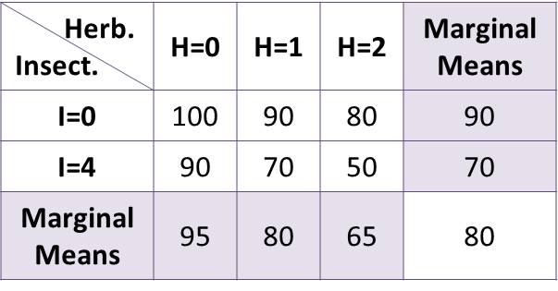

Not equal. Insecticide main effects.

Not equal. Herbicide main effects.

Contrasts I=0 and I=4 with H=0 and H=1.

(100-90) - (90-70) = -10 which is not 0. There is interaction.

**4. Interaction Plots** – also called *mean profile plot*.

Case 1 (No Interaction) Case 2 (Interaction)

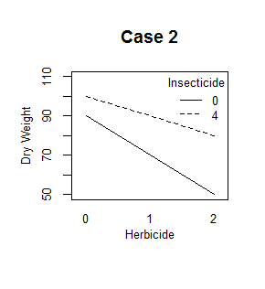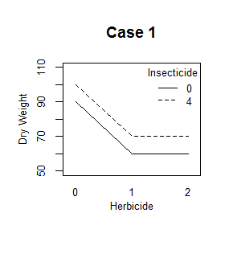

**5. Interaction and non-additivity**

No interaction Additive model

Interaction Non-additive model

**TWO WAY ANOVA – ANOVA TABLE & F-TESTS** (Hypothesis testing is based on the interaction model.)

**1. Hypothesis that we want to test.**

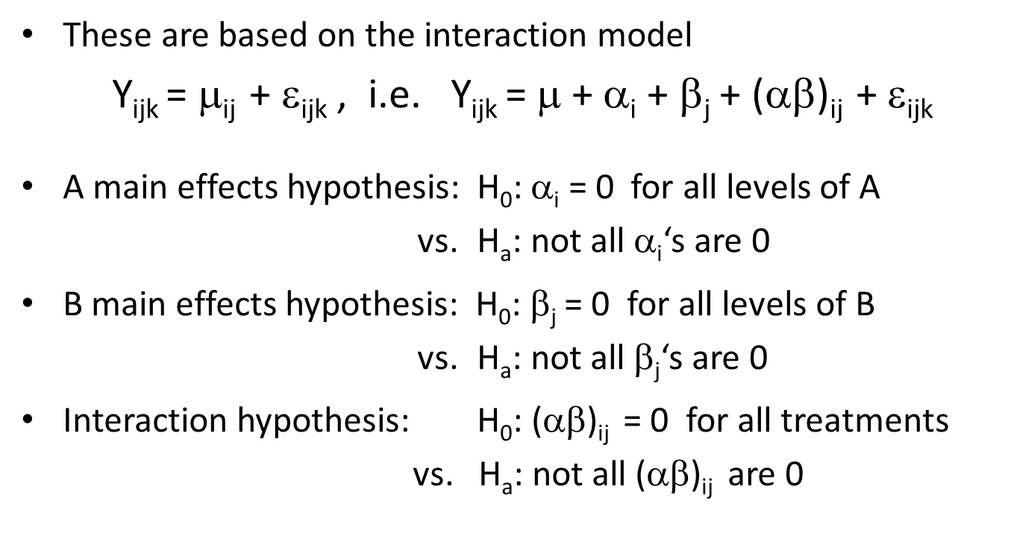

**2. Test statistics**

* Depend on the point estimates for the parameters
* Separating the total variability in the response into components attributed to
  + A main effects
  + B main effects
  + Interaction effects

**3. Least Squares Estimates for the means**

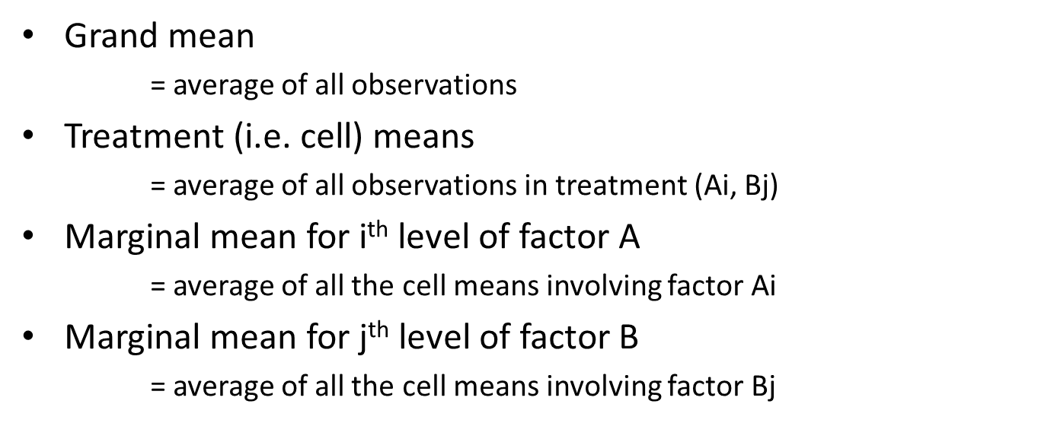

**4. Least Squares Estimates for Effects** – to estimate the main effects and interaction effects use:

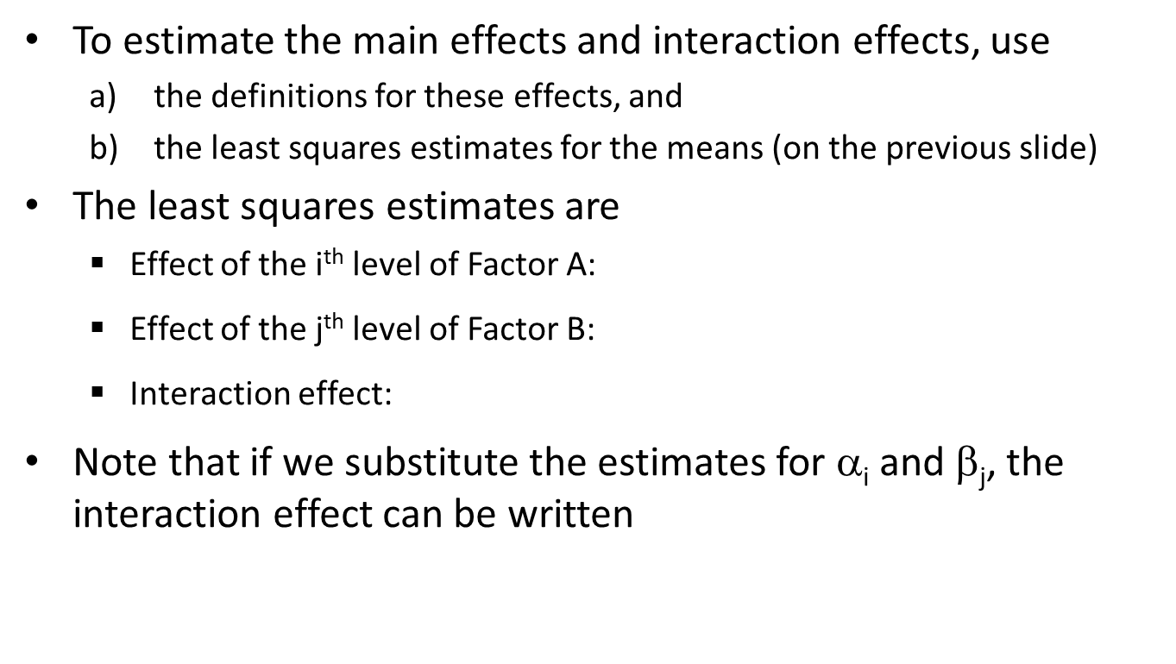

**5. Partitioning the total variation**

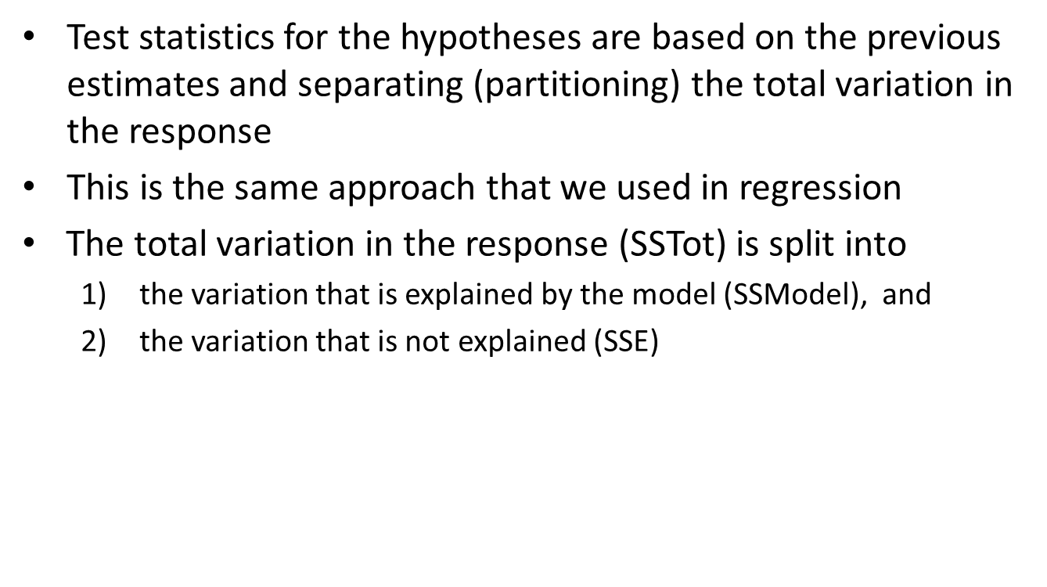

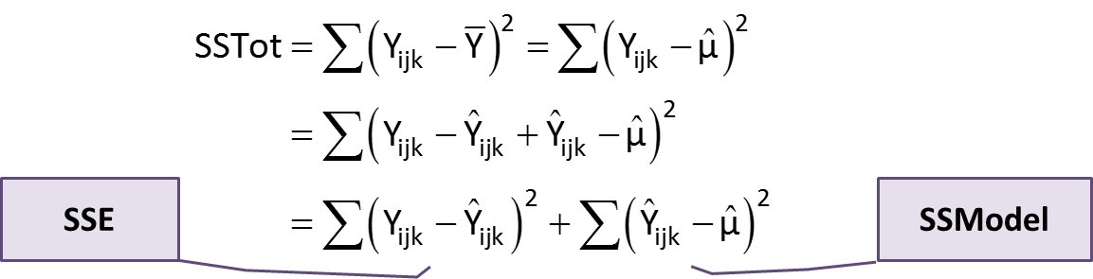

**6. Partitioning the Model** – we continue partitioning by splitting the model sum of squares into components for the effects.

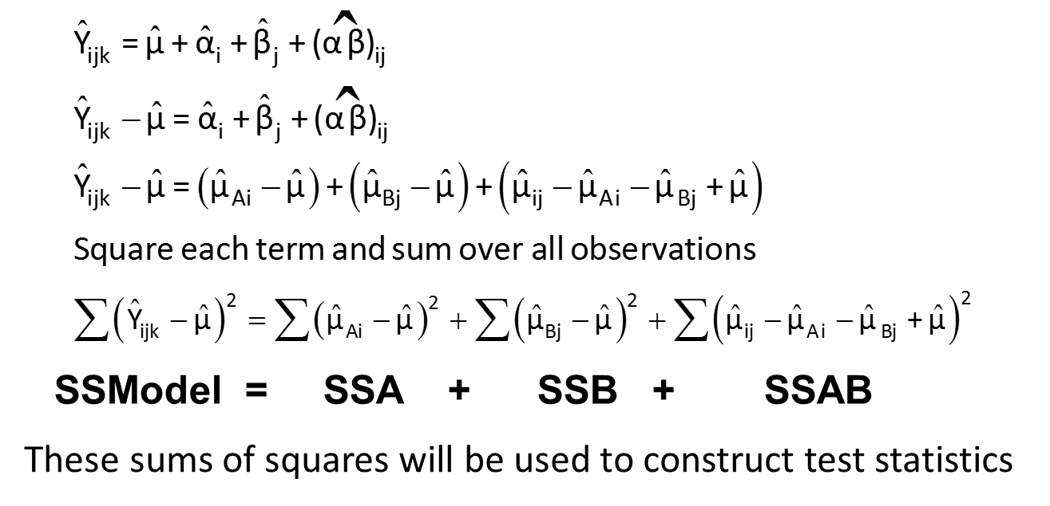

**7. Mean Squares**

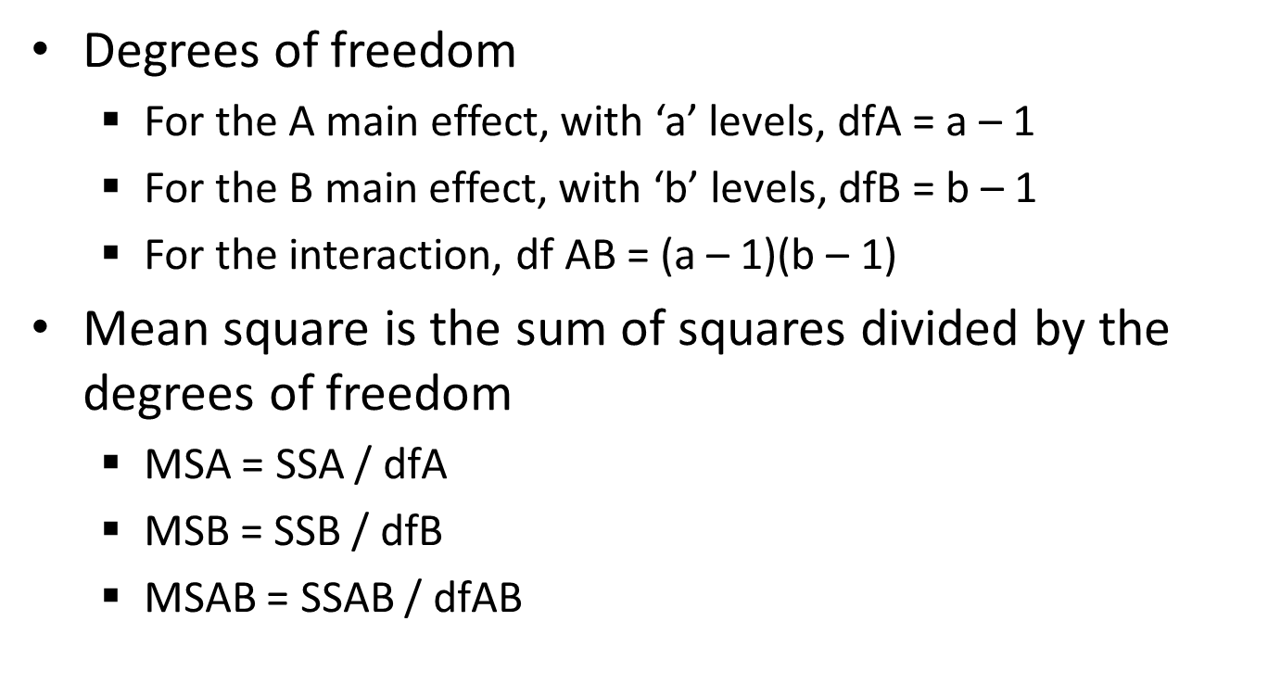

**8. Test Statistics**

* For the A main effect: H0 is αi = 0 for all levels of A
  + Test statistic is F = MSA / MSE
  + Use F distribution with degrees of freedom dfA and dfE
* For the B main effect: H0 is βj = 0 for all levels of B
  + Test statistic is F = MSB / MSE
  + Use F distribution with degrees of freedom dfB and dfE
* For the A*B interaction: H0 is (αβ)ij  = 0 for all treatments
  + Test statistic is F = MSAB / MSE
  + Use F distribution with degrees of freedom dfAB and dfE

**9. ANOVA Table for Two Way ANOVA**

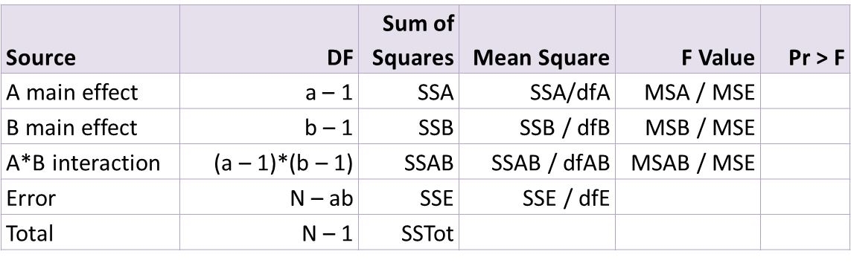

Fabric Data ANOVA Table

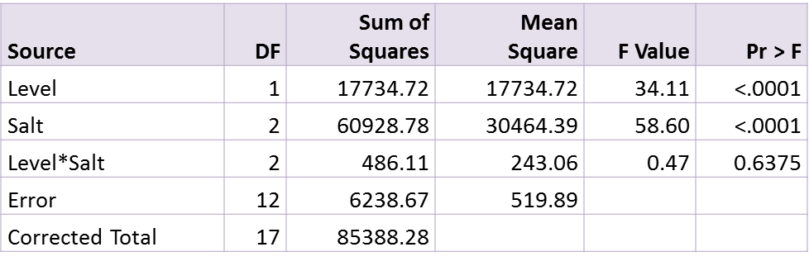

Verify the degrees of freedom

* Factor A is ‘Level’; number of levels is 2; dfA = 1
* Factor B is ‘Salt’; number of levels is 3; dfB = 2
* Interaction: dfAB = 1*2 = 2

Total number observations = N

= (number of A’s)*(number of B’s)*(number of replications)

= 2*3*3 = 18 -> dfTot = 17

**10. Interpreting the ANOVA Table**

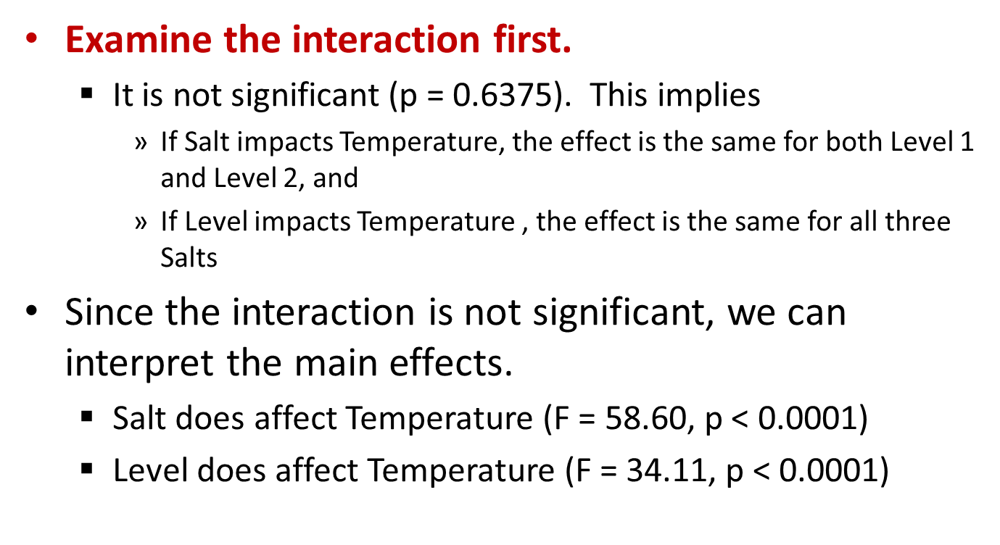

**11. Relations to Nested Model F-Test**

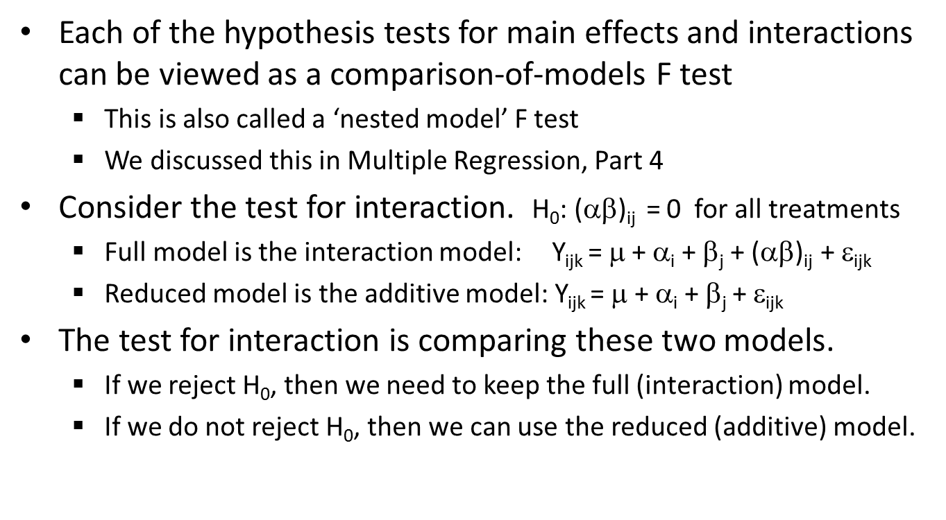

**TWO WAY ANOVA – T Test and Contrasts (Means)**

**1. Inference for Means** – requires

* Point estimate
* Standard error of the estimate
* Reference distribution (for the critical value)

**2. Standard Error of a Sample Mean** – measures how accurately the sample mean estimates the corresponding population mean

**SE = Sp/** Sp – Square root of MSE

N – number of obs that go into computing the sample mean for which we want to find the standard error.

Ex. Fabric Data

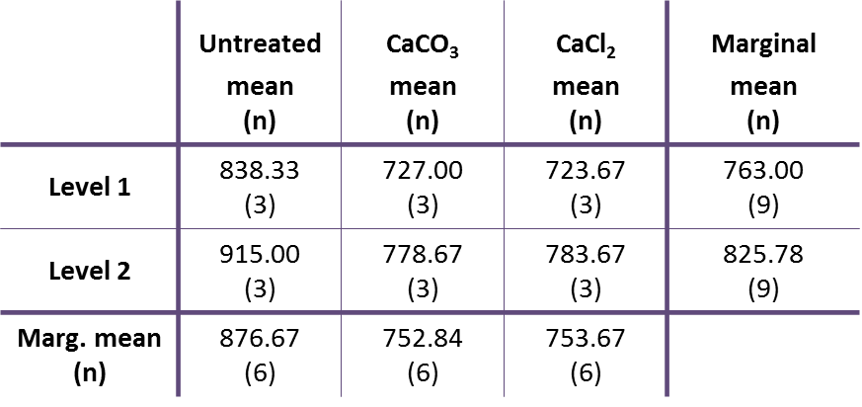 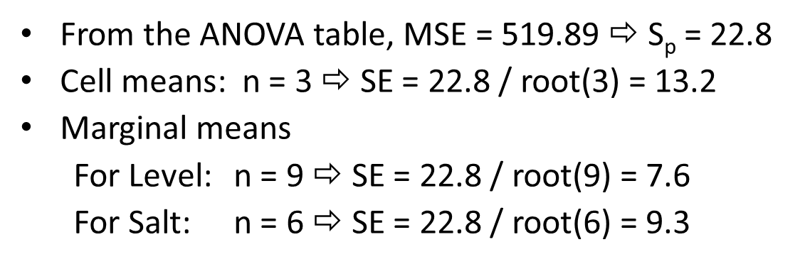

**3. Inferences on Sample Means-**we can perform hypothesis tests and construct confidence intervals for any of the sample means.

* For individual means – interested in confidence intervals
* Combinations of means – testing whether the means are equal (whether the difference is 0)

**4. Confidence Intervals for the means**

* **(sample mean) ± (critical value) x (SE)**
* Critical Value – (t-distribution with degrees of freedom (dfE))
* Confidence Interval for the ‘untreated’ marginal mean α=.05, dfE=12
  + 876.67 ± 2.179(9.3) = (856.4, 896.9)

95% of the time, we expect untreated fabric to ignite when the temperature is between 856.4 and 896.9 degrees.

**5. Difference of Means**

* Any of the treatment means

Do not involve any of the same observations.

* Marginal means for factor A
* Marginal means for factor B

**6. Hypothesis Test for Difference:**

* Hypotheses are H0: μ1 = μ2 vs. Ha: μ1 ≠ μ2
  + Can also be written H0: μ1 – μ2 = 0 vs. Ha: μ1 – μ2 ≠ 0
  + population means: μ1 and μ2 (both unknown)
* Test statistic:
* Critical value
  + Same as with a single mean
  + From the t distribution with degrees of freedom dfE

Ex. Fabric Example. Test the differences between marginal means of CaCO3 or CaCl2.

* Sample Means CaCO3 -> µ1 = 752.84 SE1=9.3
* Sample Means CaCl2 -> µ2 = 753.67 SE1=9.3
* SE Difference = + = 13.15
* CV α=.05, dfE=12 = 2.179
* TS = = 0.063
* Decision – 0.063 < 2.179, FTR Ho. There is a difference between the means. There is enough evidence to conclude that the mean temperature at which fabric ignites is different between treatments.

**7. Standard Error of the contrast**

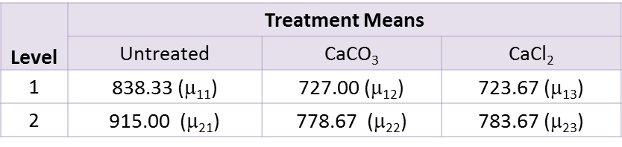

* Average of CaCO3 and CaCl2 at Level 1 = (μ12 + μ13)/2
* Average of CaCO3 and CaCl2 at Level 2 = (μ22 + μ23)/2
* Contrast = (μ12 + μ13)/2 – (μ22 + μ23)/2

= ½ μ12 + ½ μ13 - ½ μ22 - ½ μ23

* From the ANOVA table, MSE = 519.89 and dfE = 12
* SE of contrast =



Hypotheses H0: ½ μ12 + ½ μ13 – ½ μ22 – ½ μ23 = 0 vs. Ha: ½ μ12 + ½ μ13 – ½ μ22 – ½ μ23  ≠ 0

Estimate of contrast: ½ (727 + 723.67) – ½ (778.67 + 783.67) = –55.835

Test statistic: t = (estimate) / (standard error) t = –55.835 / 13.164 = –4.241

Critical value = 2.179 (from t distribution with df = dfE = 12)

Decision: Reject H0  : because |–4.241| > 2.179

At significance level 0.05, the average temperature for CaCO3 and CaCl2is different between levels 1 & 2.

**GENERALIZATIONS: THREE WAY ANOVA**

1. Multiple factor studies are focused on identifying how the factors work together to affect the outcome.

Ex. Study was done to determine factors that may affect the efficiency of a solar water heater. The factors are:

* The capacity
* The flow rate
* Length of exposure of the solar collector to direct sunlight

Two levels (Low and High)

* Cap (low, high)
* Flo (low, high)
* Exp (low, high)

Response is efficiency.

Data Set:

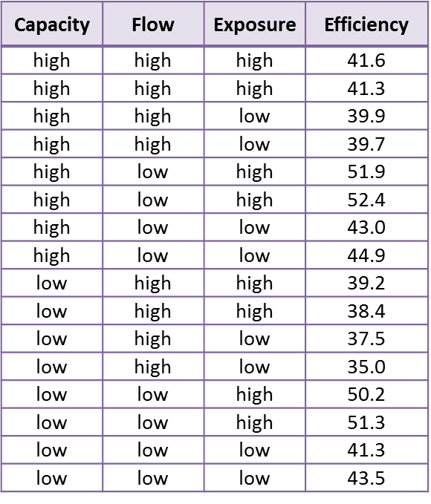 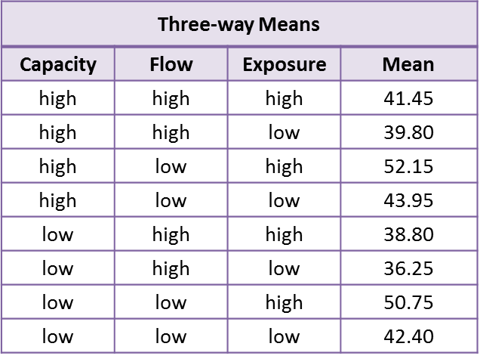 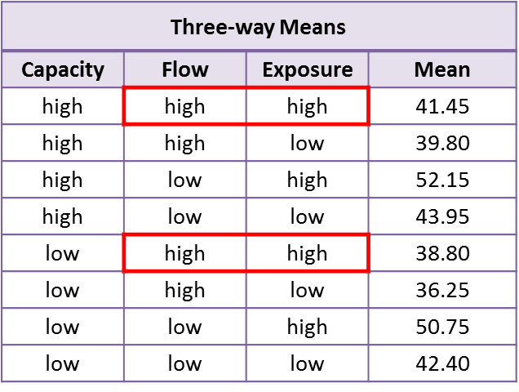

**Three Way Means**

* There are two replicates for each combination of factors
* Average the two replicates to get the three-way means

**Two Way Means**

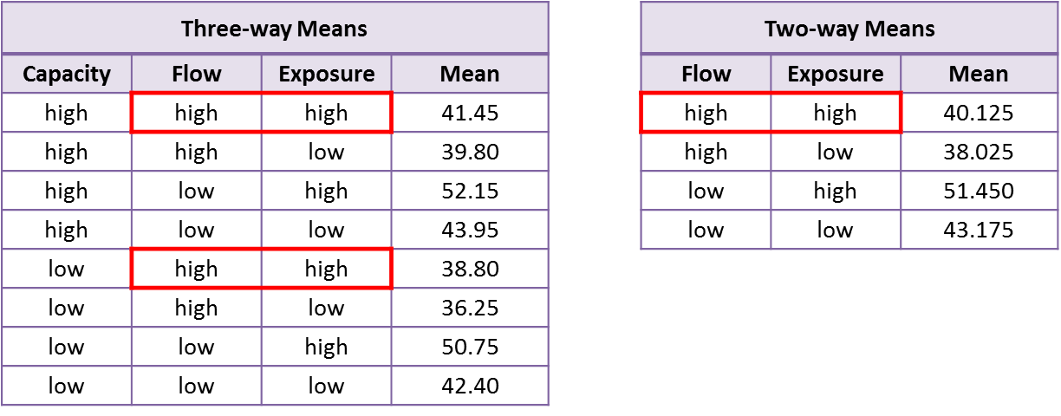

For example . . .

for high Flow and high Exposure, the two-way mean is

(41.45 + 38.80) / 2 = 40.125

* These are the means for each of the combinations of the levels of two factors when averaged over the levels of the third factor.
* Two-way means for Flow by Exposure are shown below.

**One Way Means**

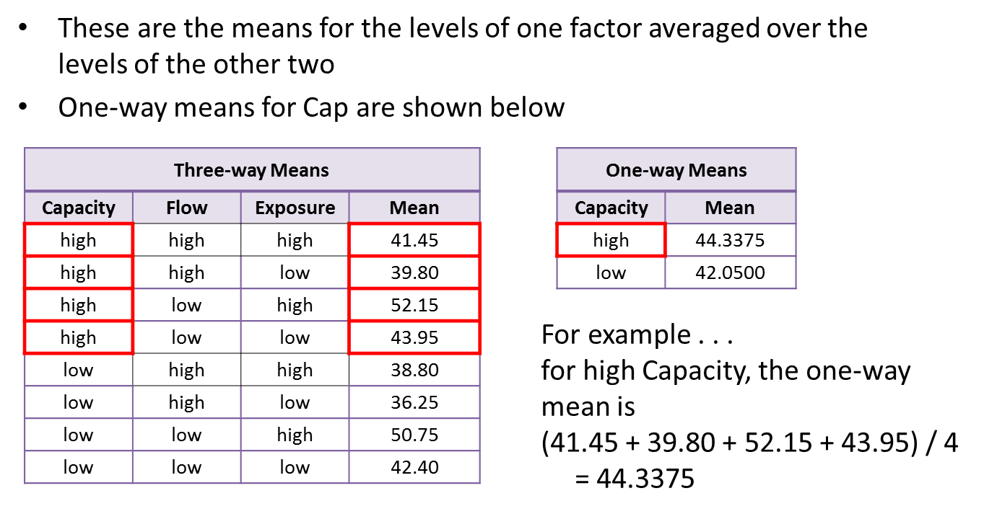

**Three Way ANOVA Table**

* Denote the factors by A, B, C
* The ANOVA table contains sums of squares, degrees of freedom, mean squares, F-statistics and p-values for
  + A, B, C main effects
  + Two-way interactions: A*B, A*C, and B*C
  + Three interaction: A*B*C
  + Error

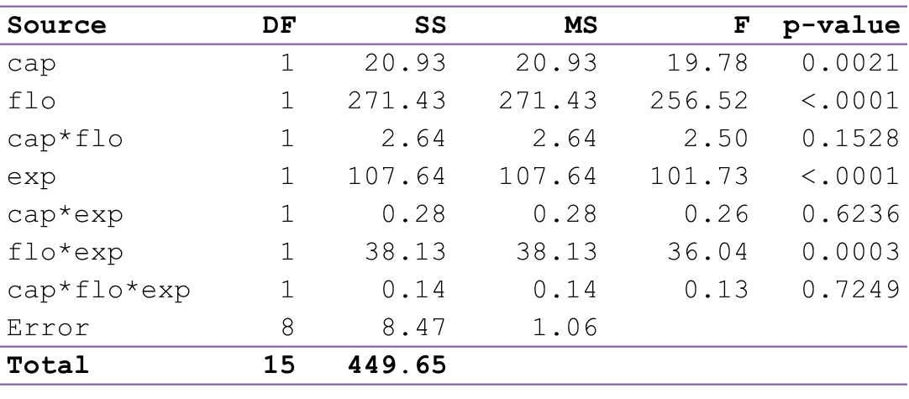

**Interpreting the ANOVA Table**

Use the significant terms in the ANOVA table to direct your attention to the most important means to look at

* If the 3-way interaction is significant, look at the 3-way means
* If the 3-way interaction is not significant, look at the 2-way means for any factors that have significant 2-way interactions
* If a factor is not involved in a significant 3-way or 2-way interaction but has a significant main effect, then look at the one-way means involving this factor

Example

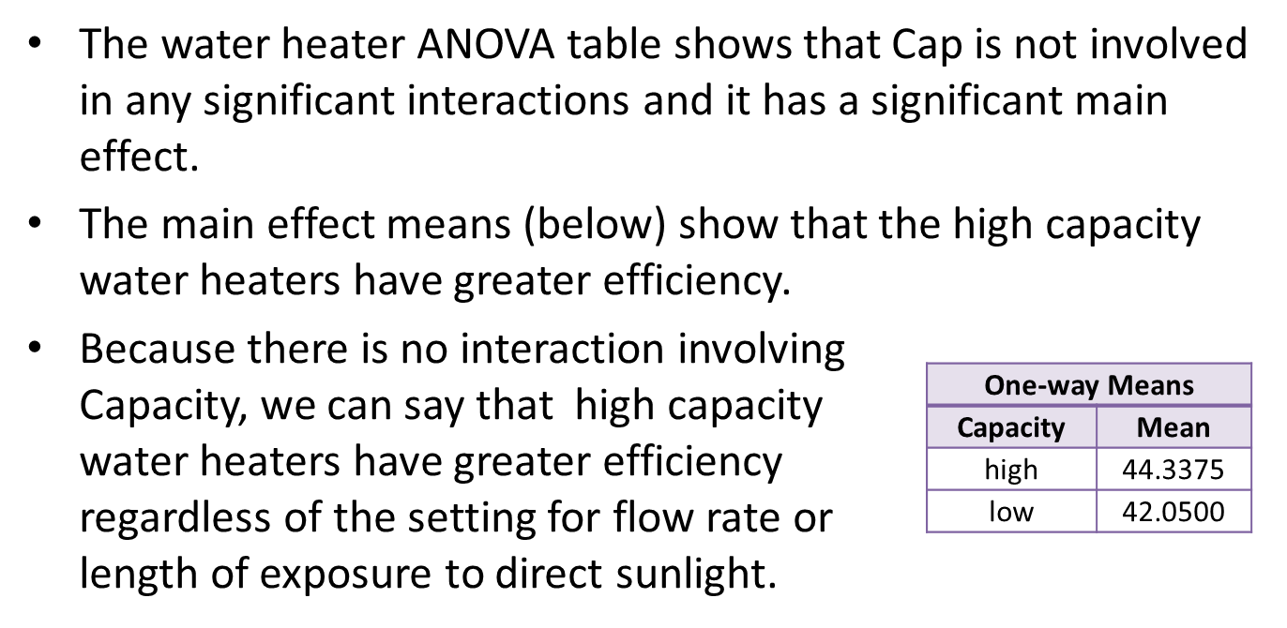

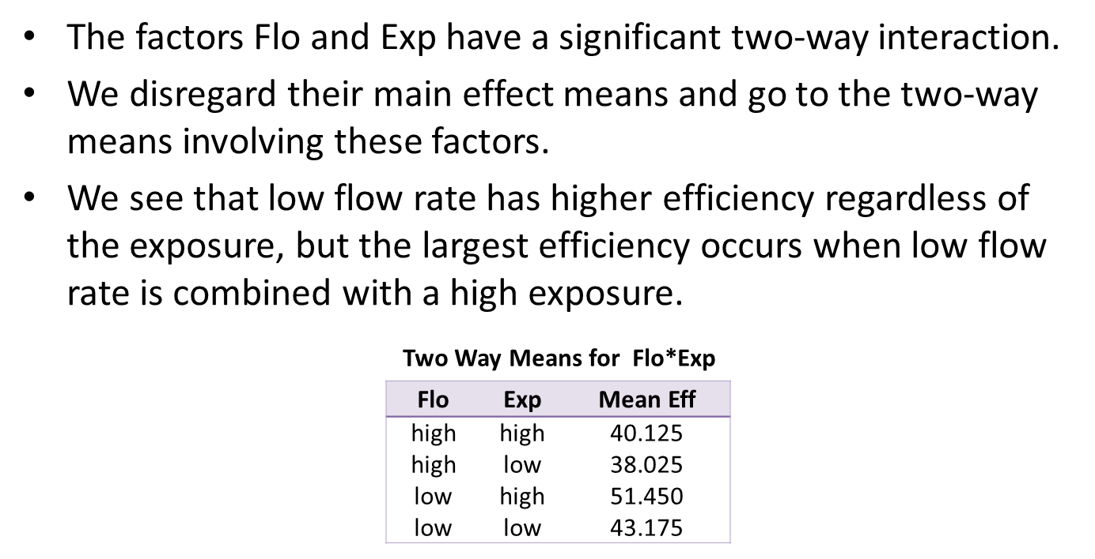

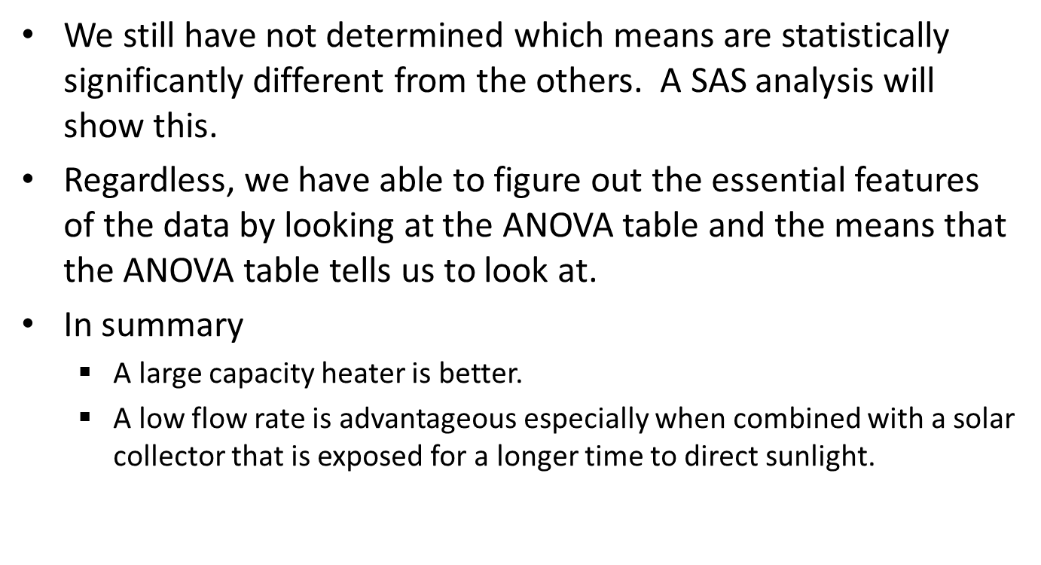

**RANDOMIZATION AND BLOCKING**

**1. Properties:**

* Bias to be small
* Random variation to be small

**2. Terminology**

* Experimentation is the process of applying treatments to experimental units and measuring the responses.
* The statistical design of an experiment is the plan that determines which experimental units go with which treatments.
* Randomization and blocking are essential elements in devising the plan for data collection.

**3. Completely Randomized Design (CRD)** – experimental units are assigned randomly to treatments.

* This is the resulting plan that shows which treatments are applied to which plots.
* The agronomist would fertilize the plots according to this plan.
* Note that there are three plots (experimental units) that receive each treatment, so this design is balanced.

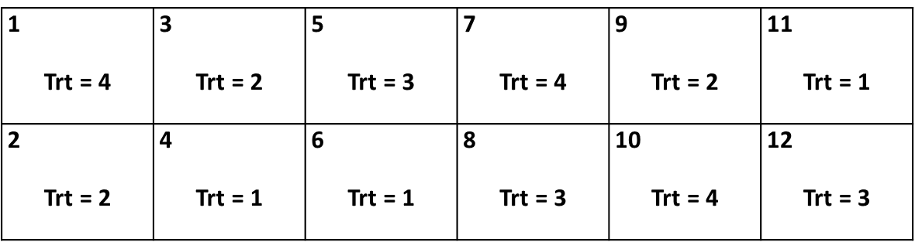

**4. Blocking**

* A block is a group of experimental units that have the same characteristics.
* Units within a block are homogeneous.
* Units in different blocks may differ.

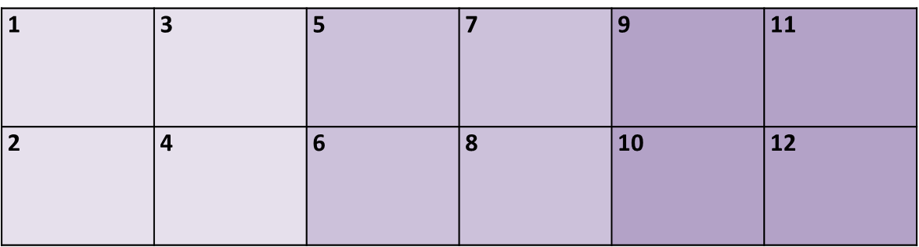

**5. Randomized Complete Block Design (RCB):**

* Each block has the same number of experimental units as there are treatments.
* All treatments appear once in each block.
* Within each block, experimental units are randomly assigned to treatments.

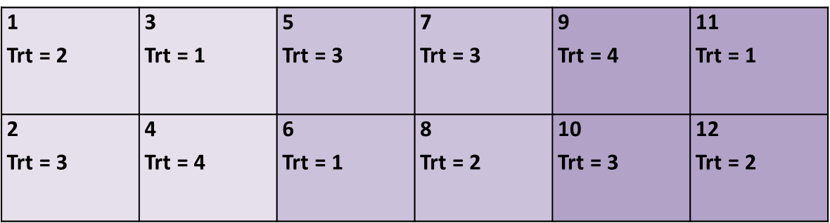

**Analysis of the RCB design**

* In the analysis of the randomized complete block design (RCB) we will assume that the effect of the blocking factor is additive.
* In other words, we assume that, in going from one block to another the responses (on average) will either increase the same amount or decrease the same amount as a result of the changing block conditions, regardless of the effects of the treatments.
* Another way to say this is that there is no interaction between the blocks and the treatments.

**Model:**

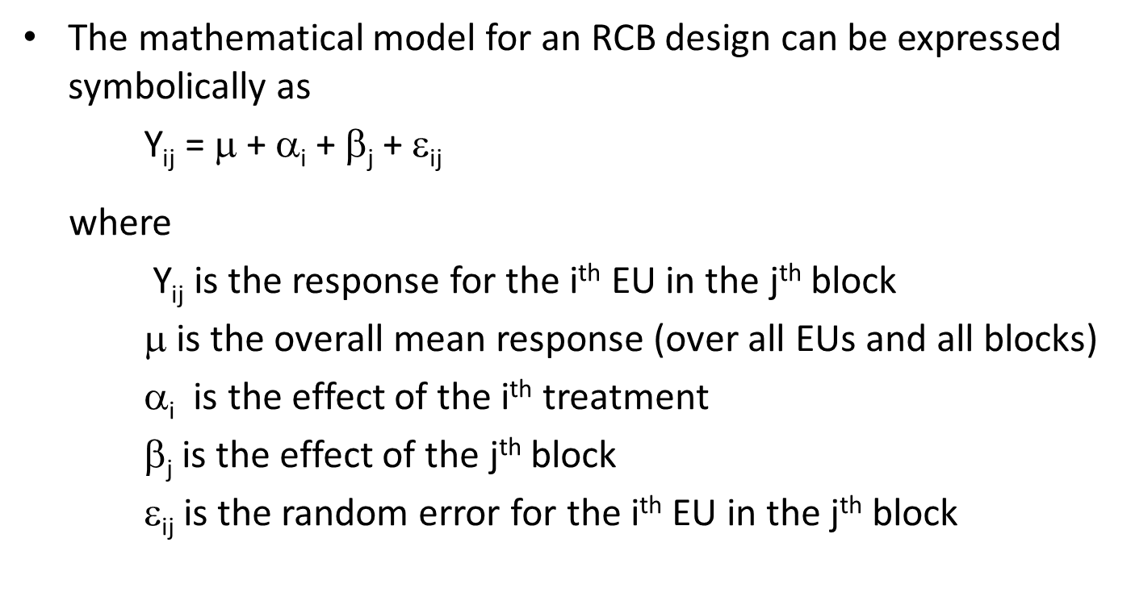

**Degrees of Freedom**

* Suppose that there are “t” treatments and “b” blocks.
* Because treatments appear once in each block, the total number of observations in an RCB is tb.
* Total df = tb – 1
* df treatments = # treatments – 1 = t – 1
* df blocks = # blocks – 1 = b – 1
* df error = Total df – df treatments – df blocks

= (tb – 1) – (t – 1) – (b – 1)

= (t – 1)(b – 1)

Example:

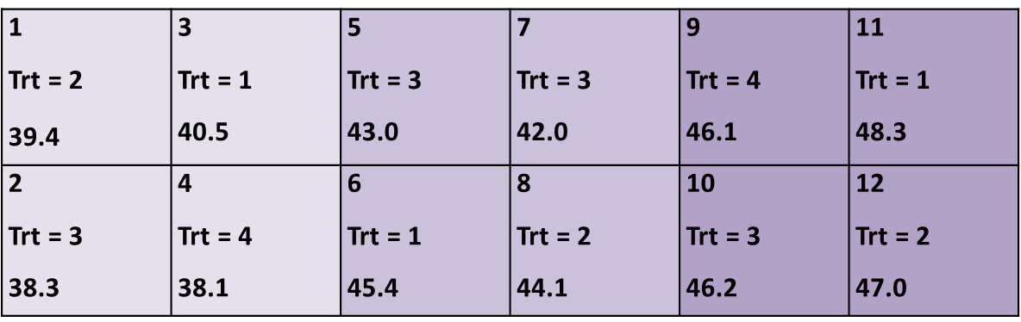

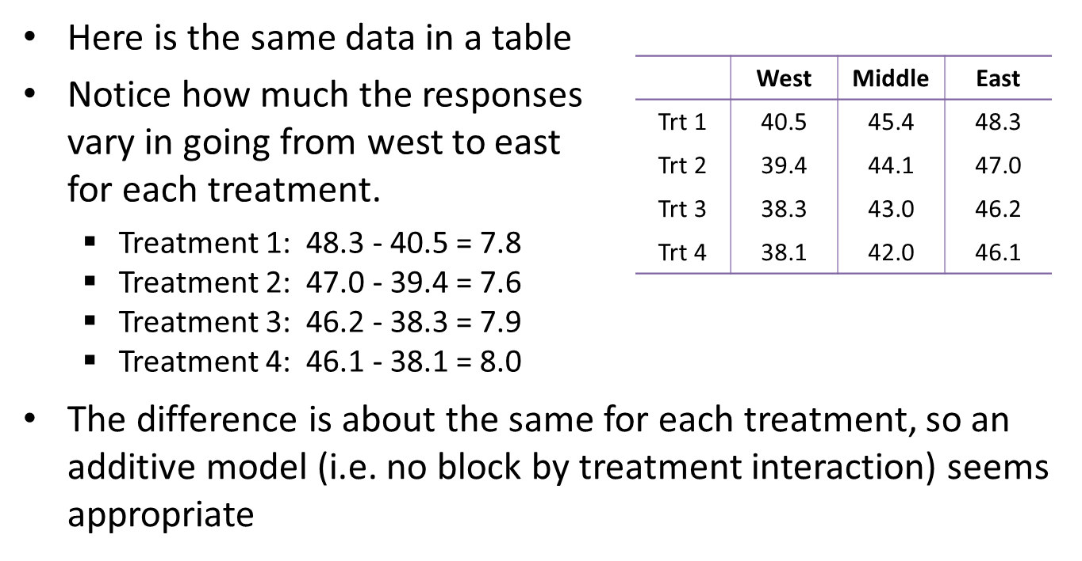

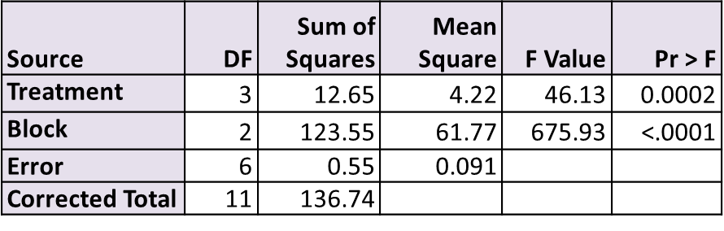

When we account for the blocking factor and do an analysis of the blocked design, then we see that treatment is highly significant (p = 0.0002).

**Factorial Treatments for RCB**

* Suppose there are two factors A and B that comprise the factorial treatment combinations.
* For example, the four fertilizer treatments in our agronomy example might consist of combinations of Nitrogen (0, 10) and Phosphorus (0, 5).
* We may assume that the factors A and B interact with each other, so that an A*B term may be included in the model.
* However, there would be no interactions between the block and A or the blocks and B.